1. Create IAM Admin User as - admin_user and assign Admin Permissions

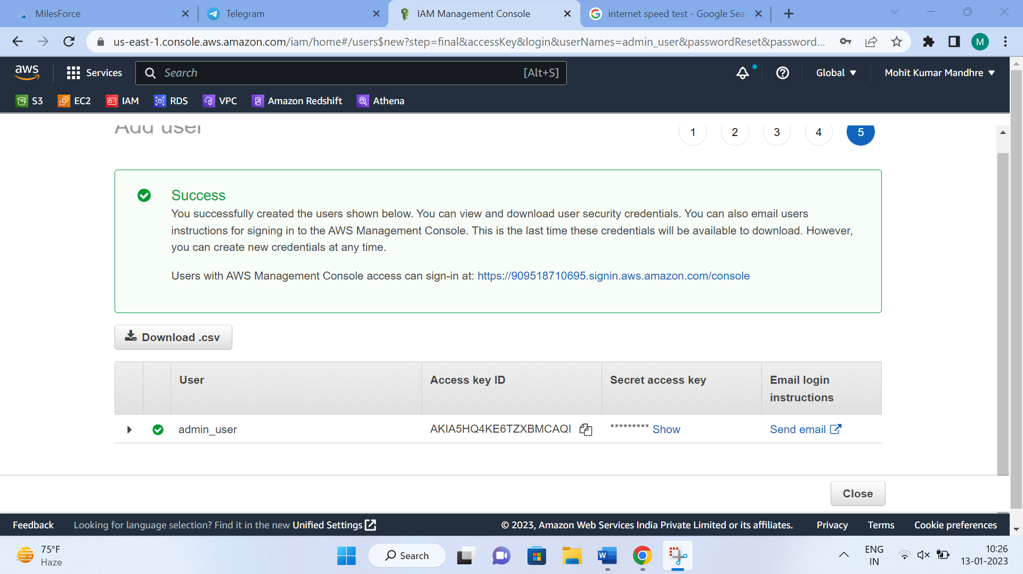

2. Create 3 IAM Developers.

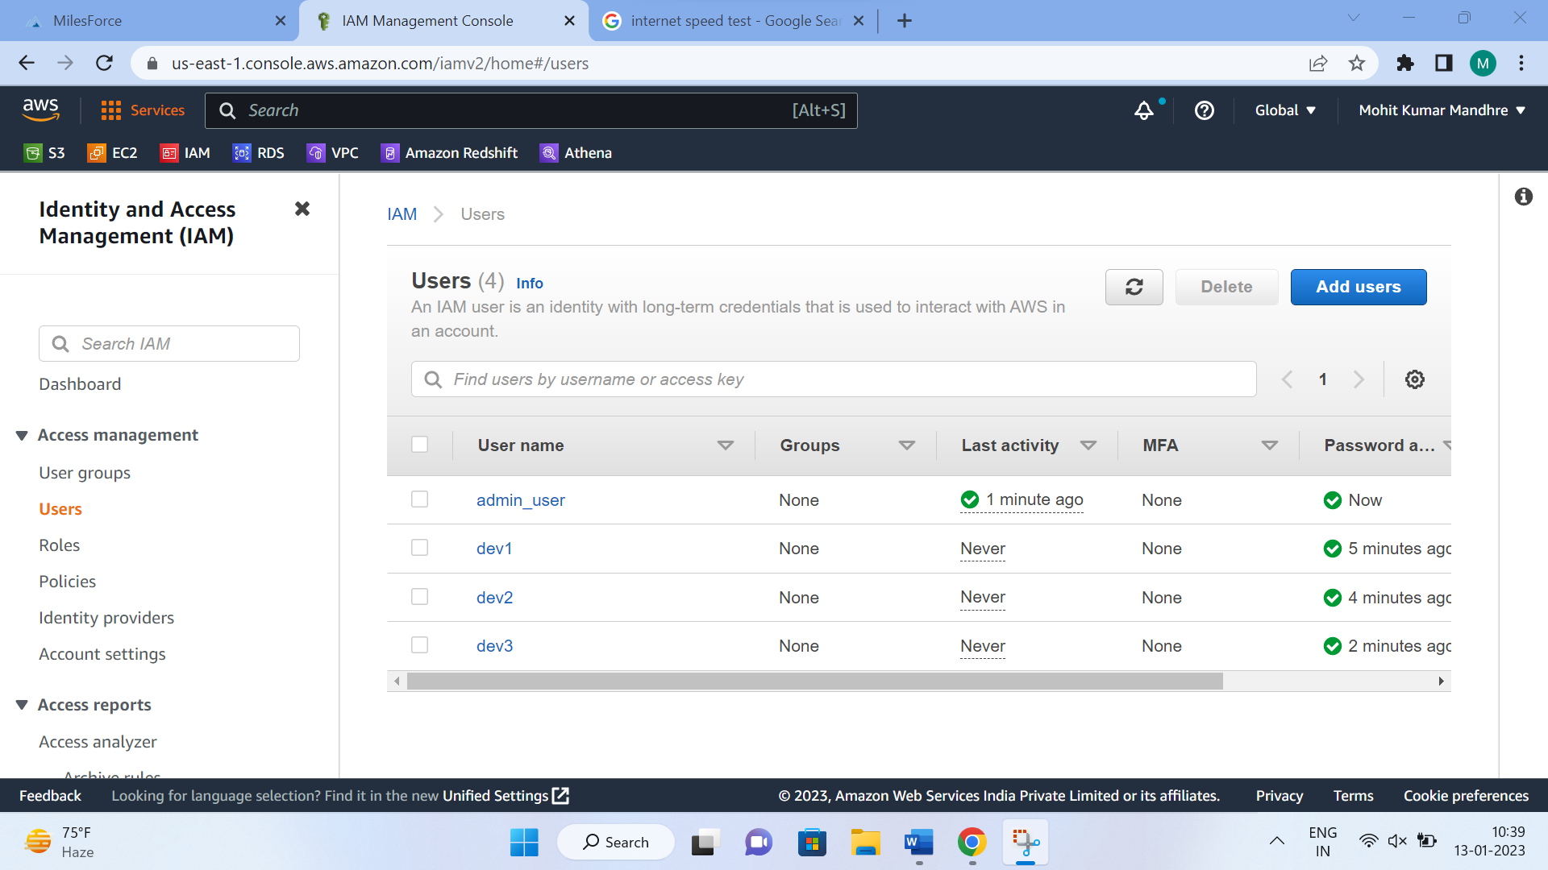

3. Create IAM User Group under Developer Group and add these 10 IAM users. Add Permissions of EC2, S3 and VPC.

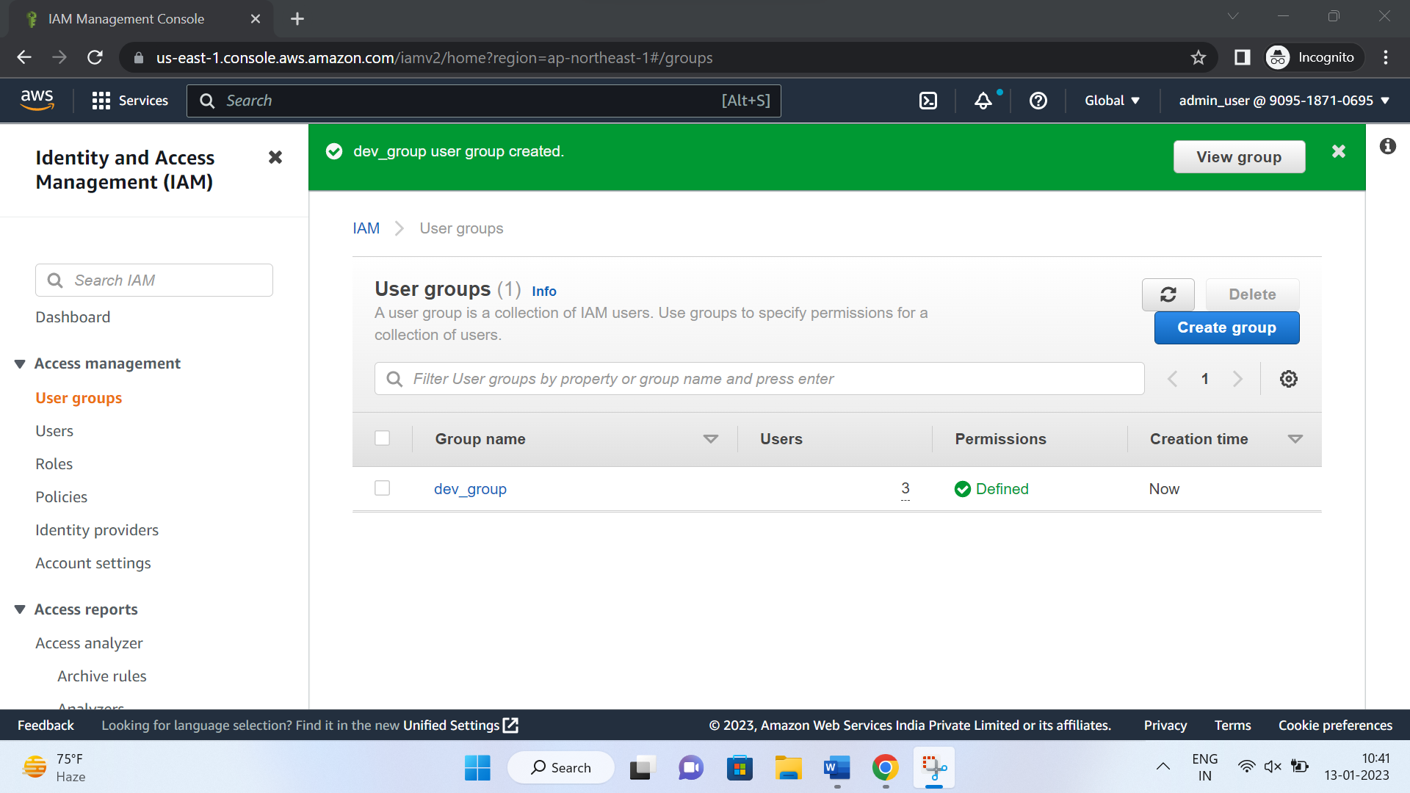

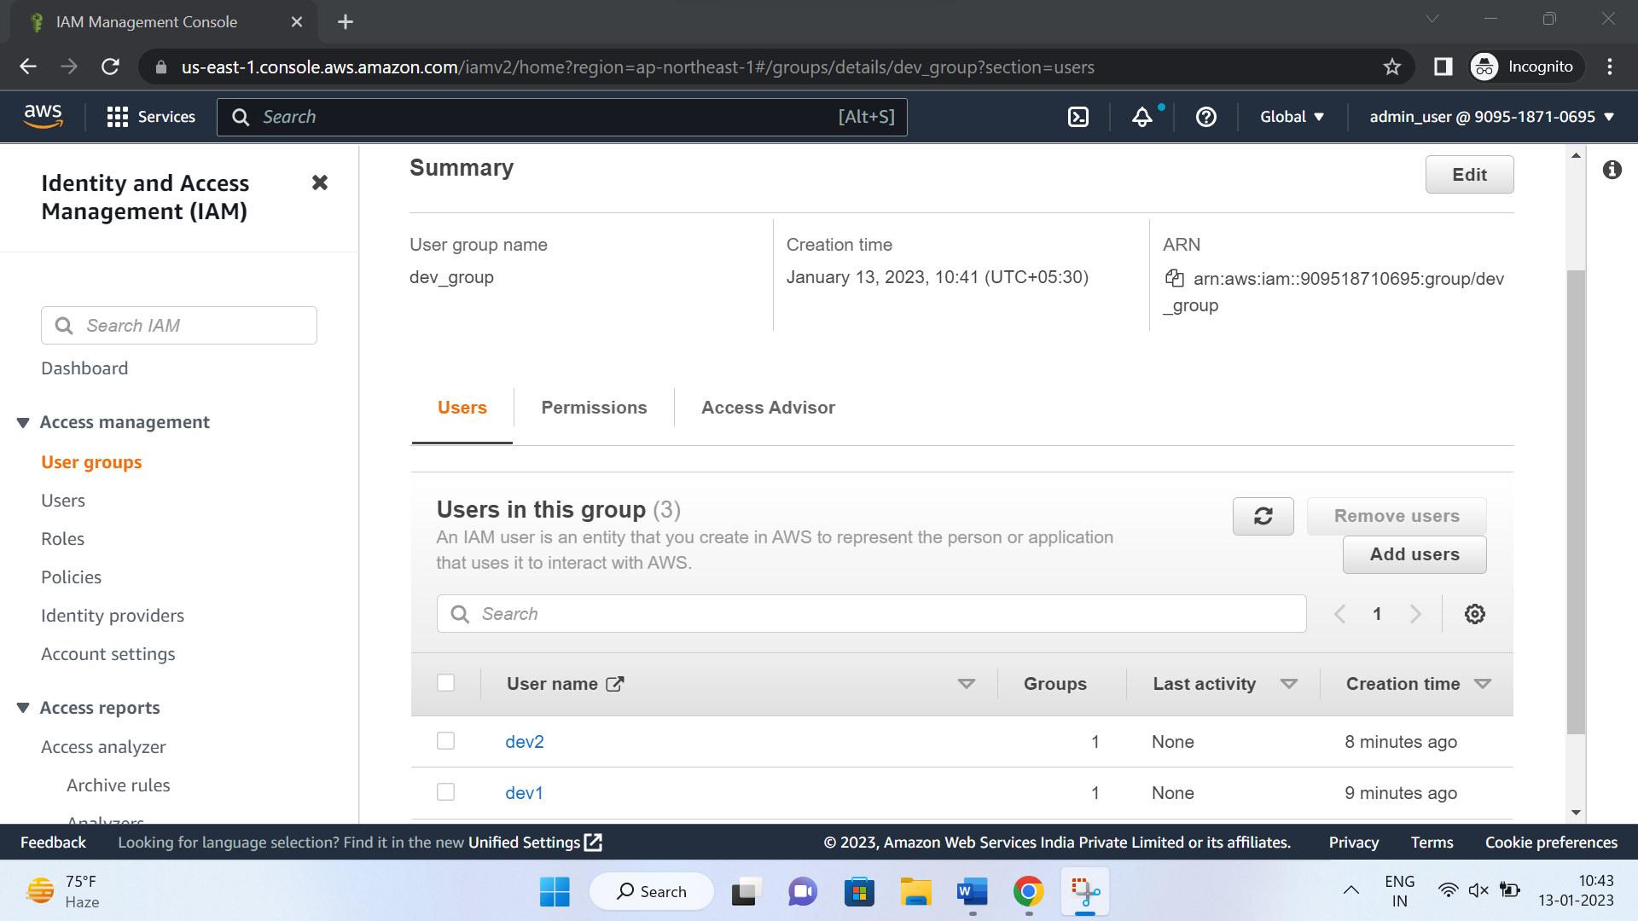

4. Create EC2 Instance with name 'Gameserver1'

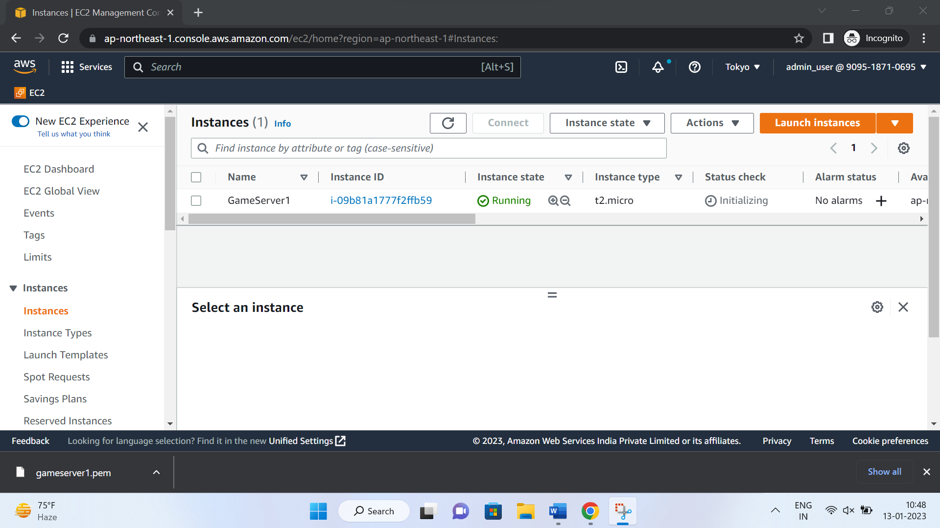

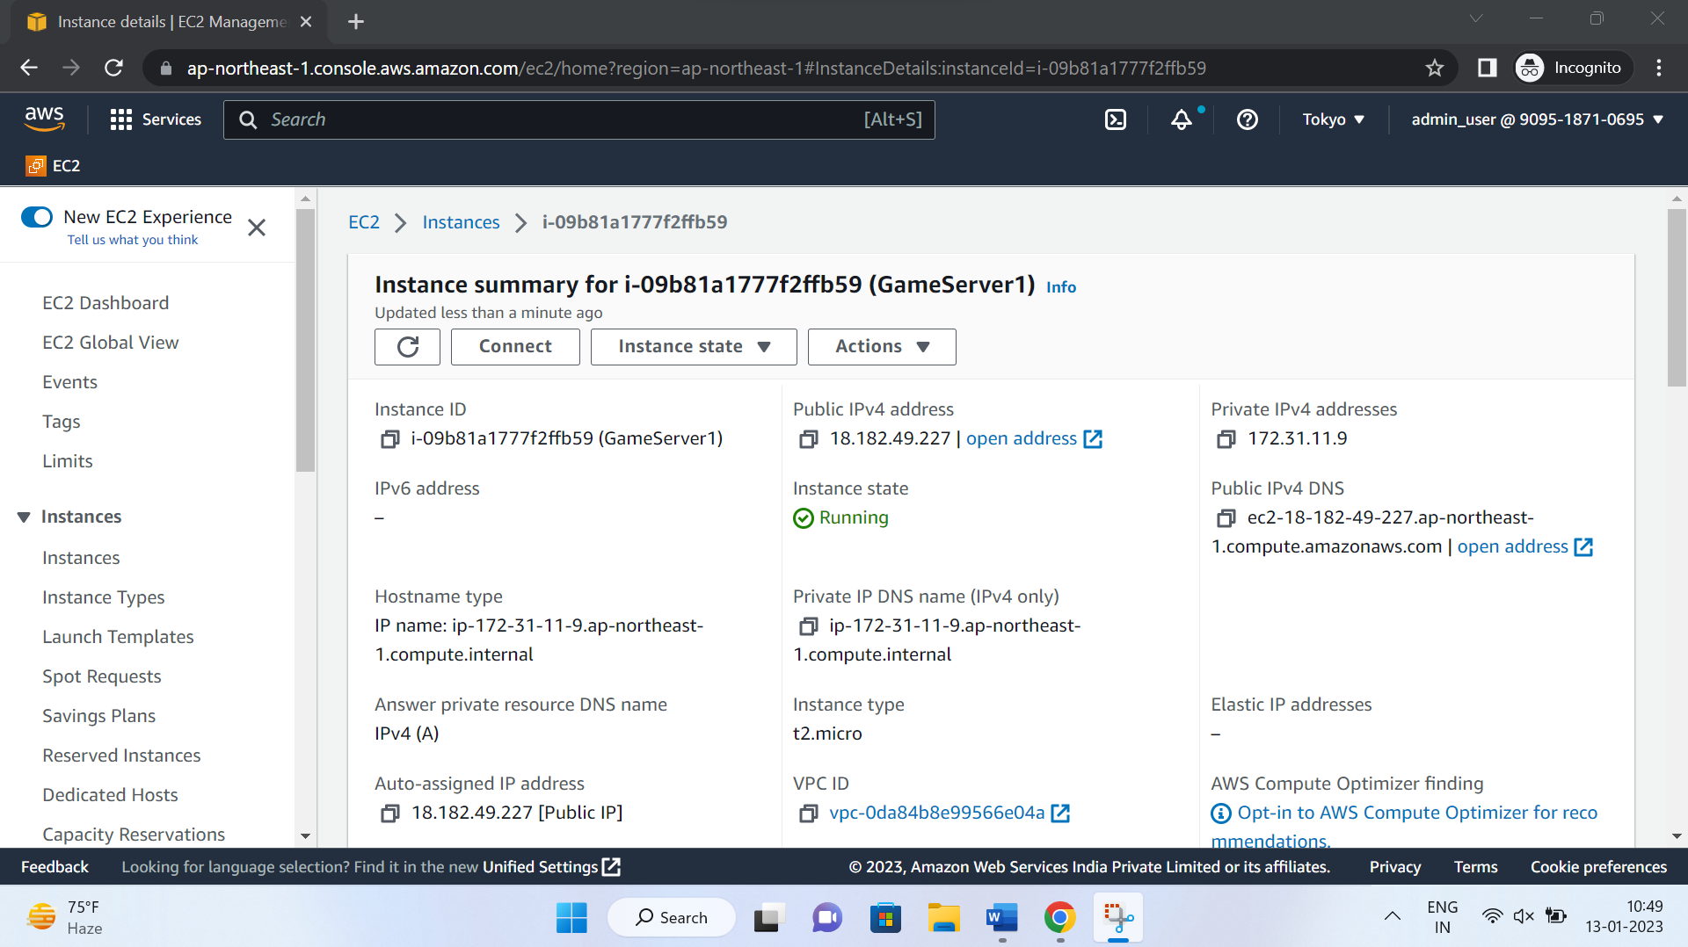

5. Create a VPC - VPC1 with CIDR 20.0.0.0/16

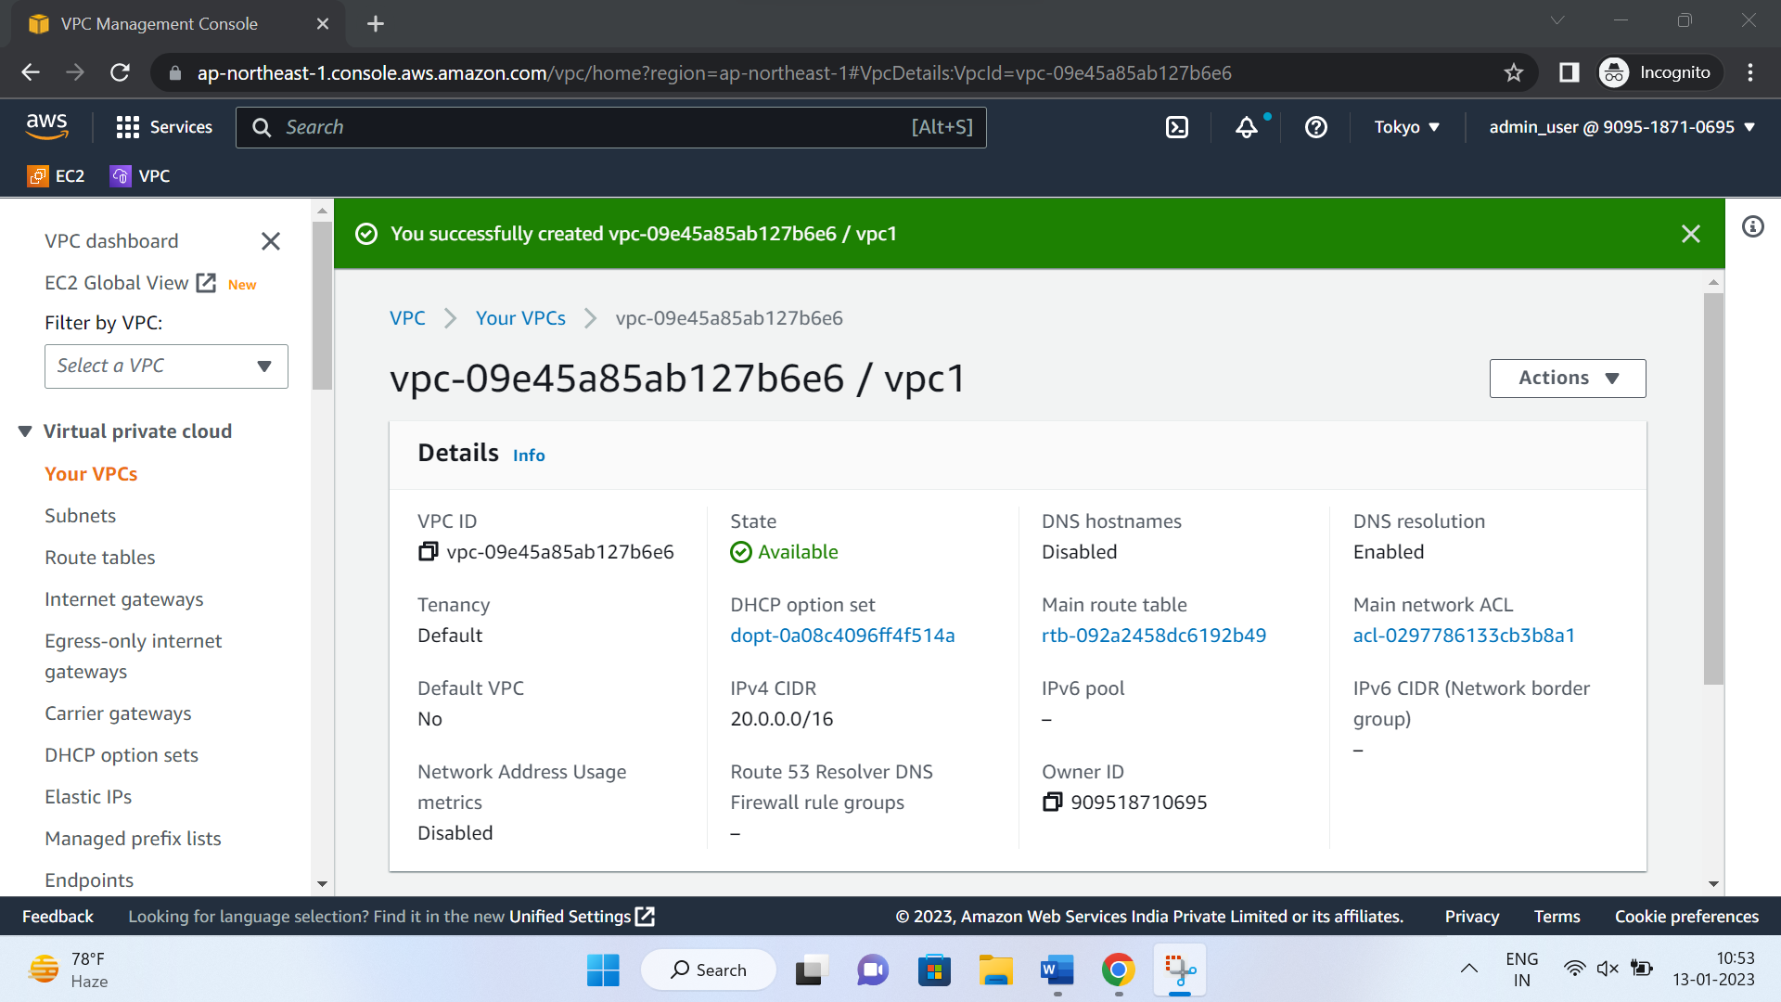

6. Create 4 Subnets each with equal IP addresses. Assign their respective CIDR blocks (As I taught - how to assign CIDR blocks and divide them among subnets)

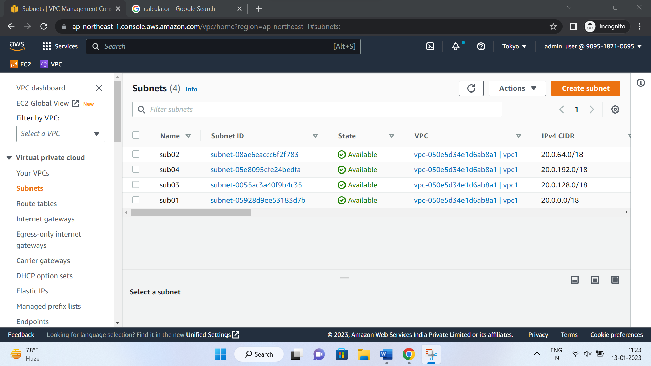

7. Create 2 Route Tables each for one subnet

* Note – a route table can be associated with multiple subnets. However, a subnet can only be associated with one route table at a time.

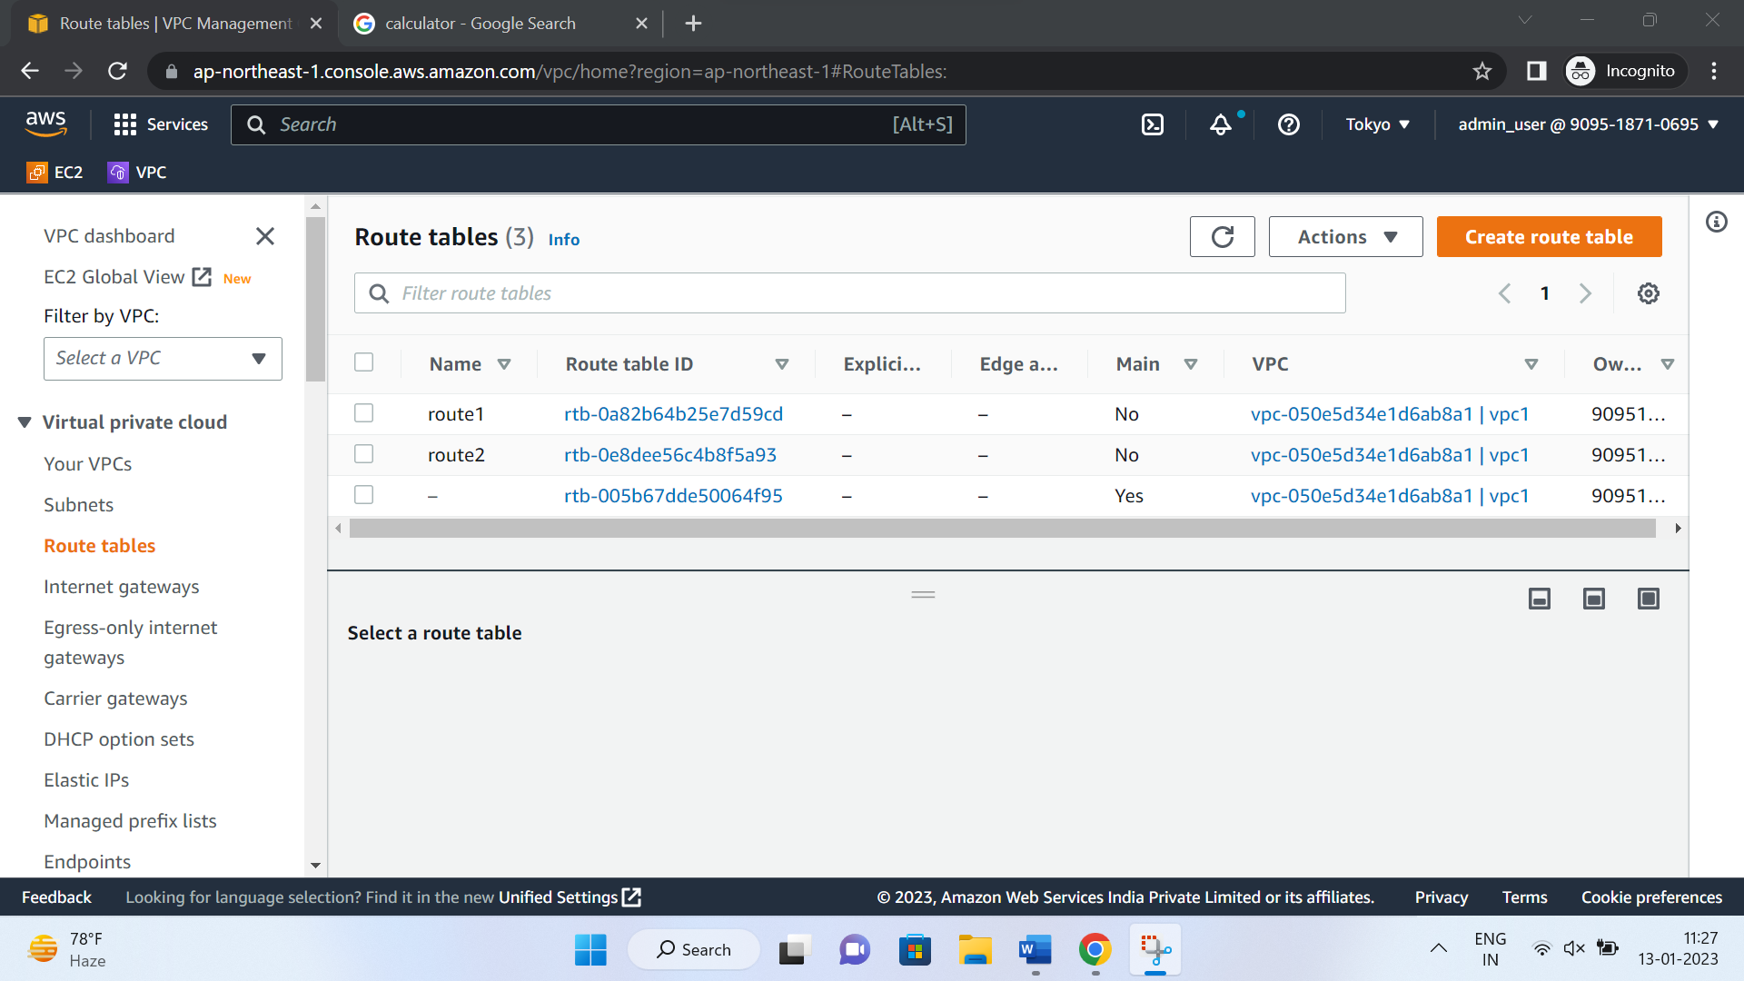

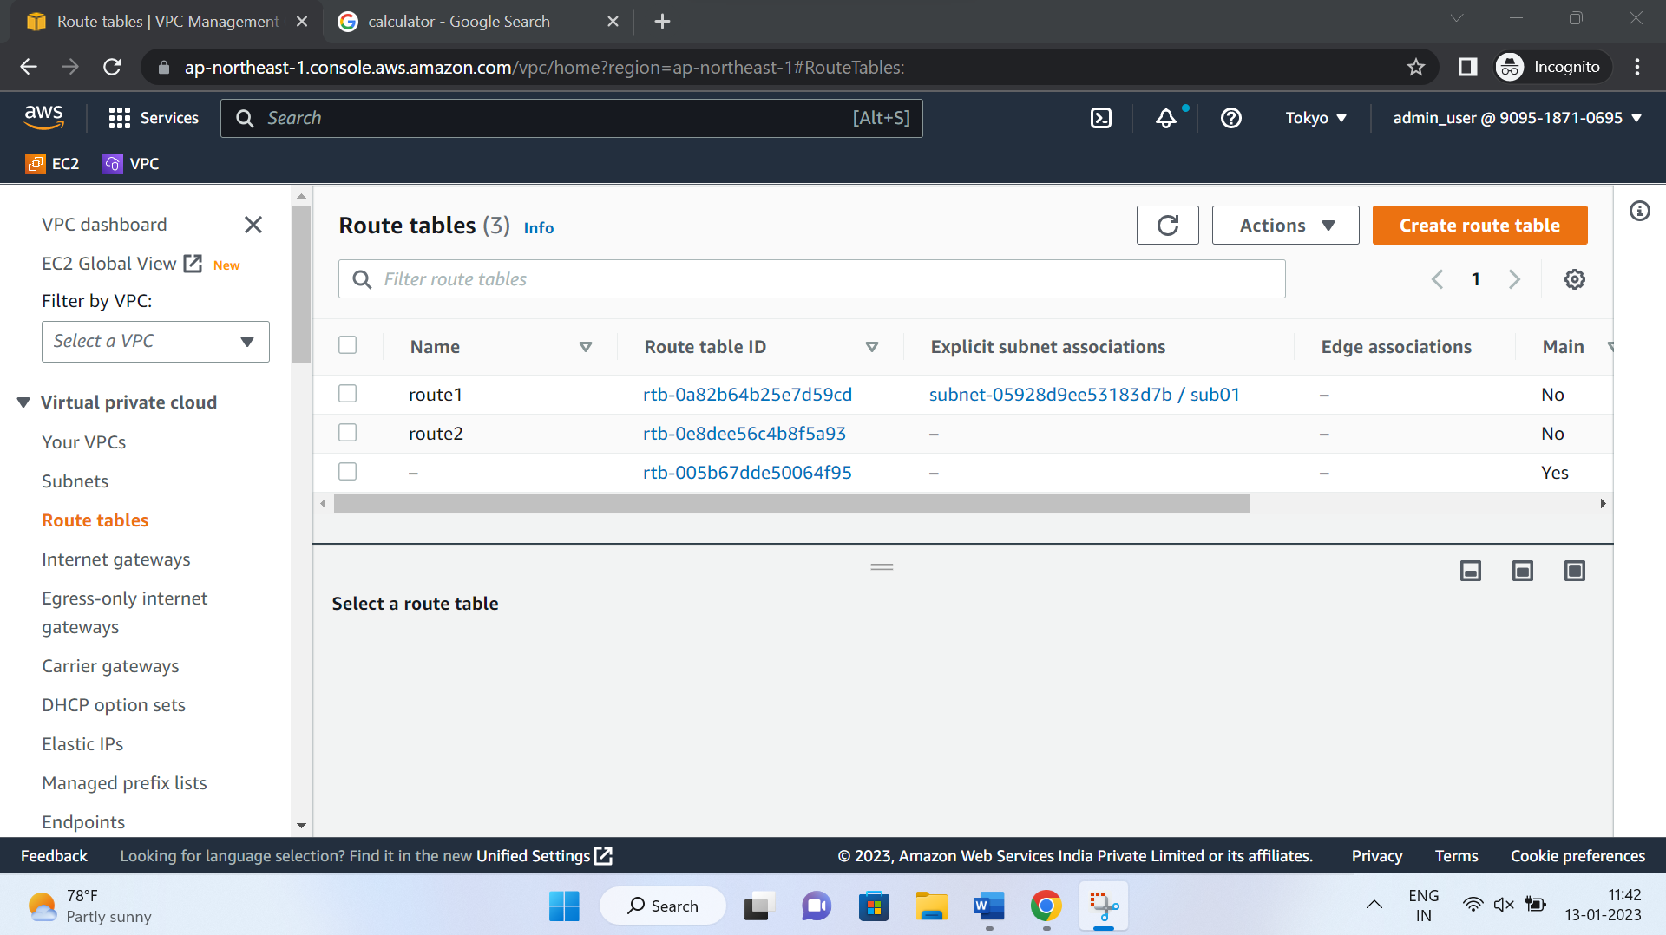

8. Create Internet Gateway and attach it to the VPC we just created.

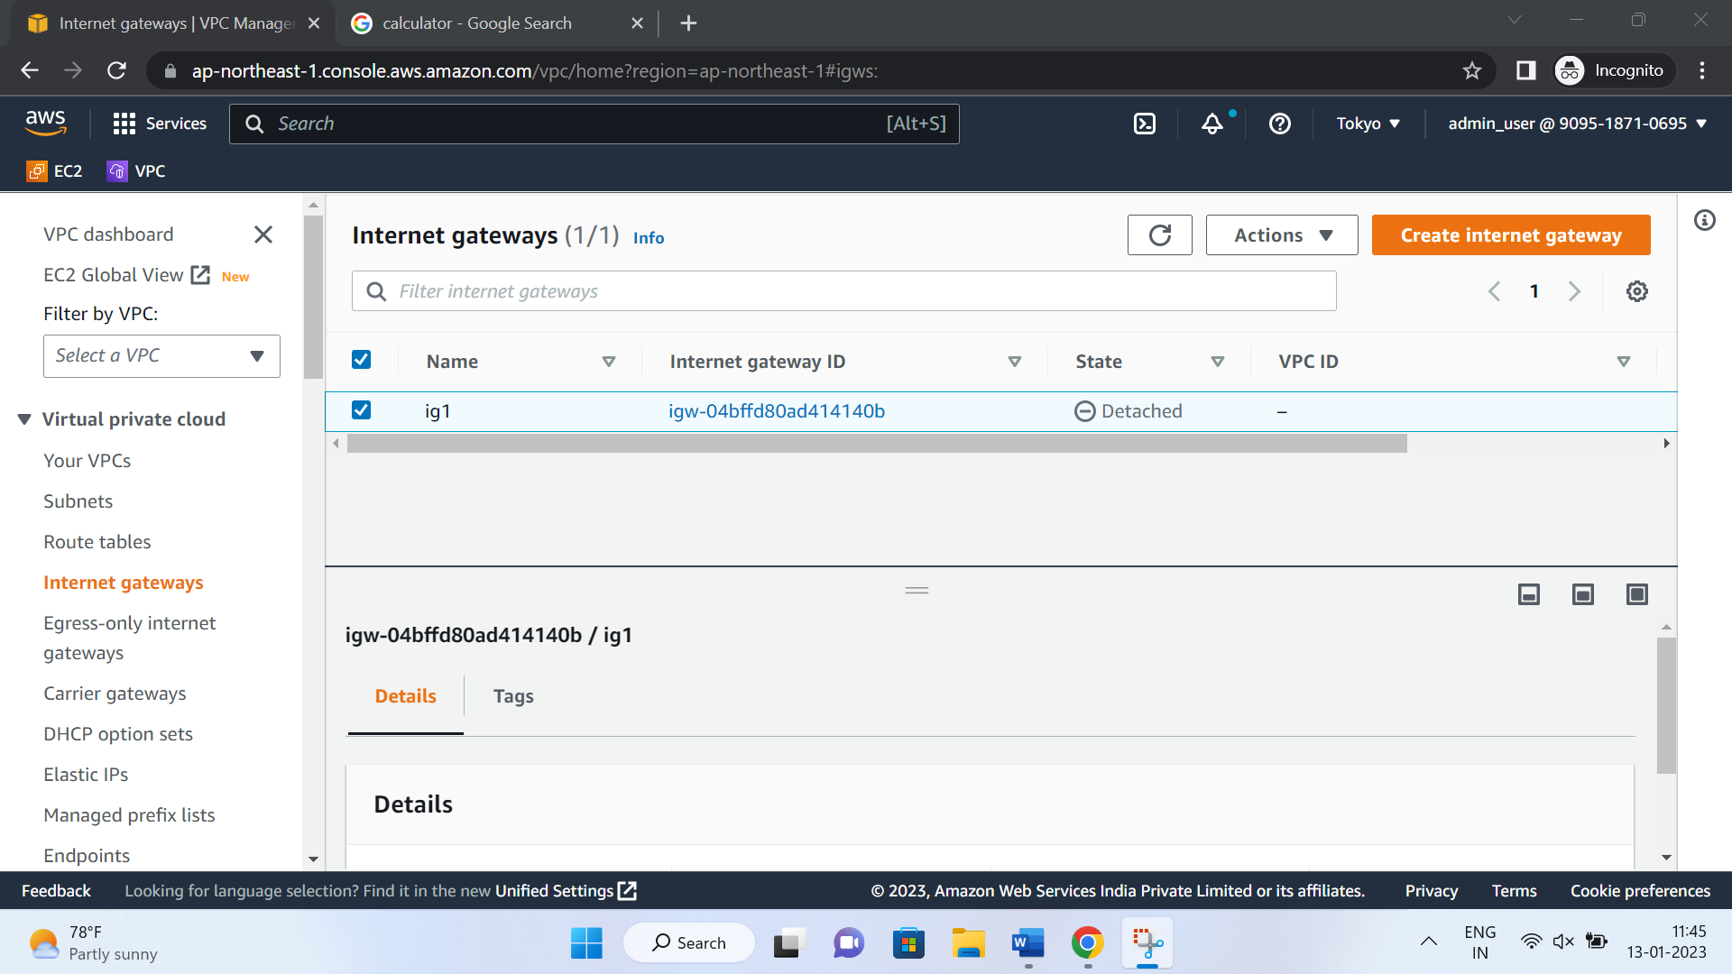

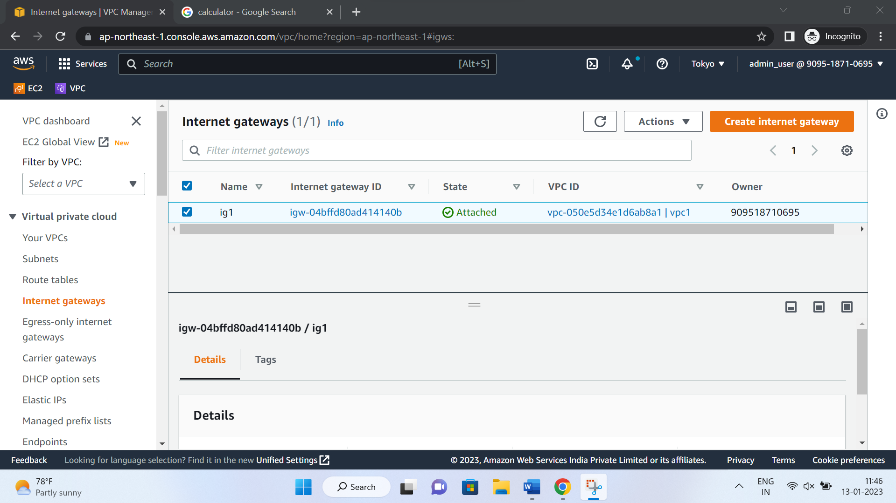

9. Create an S3 Bucket

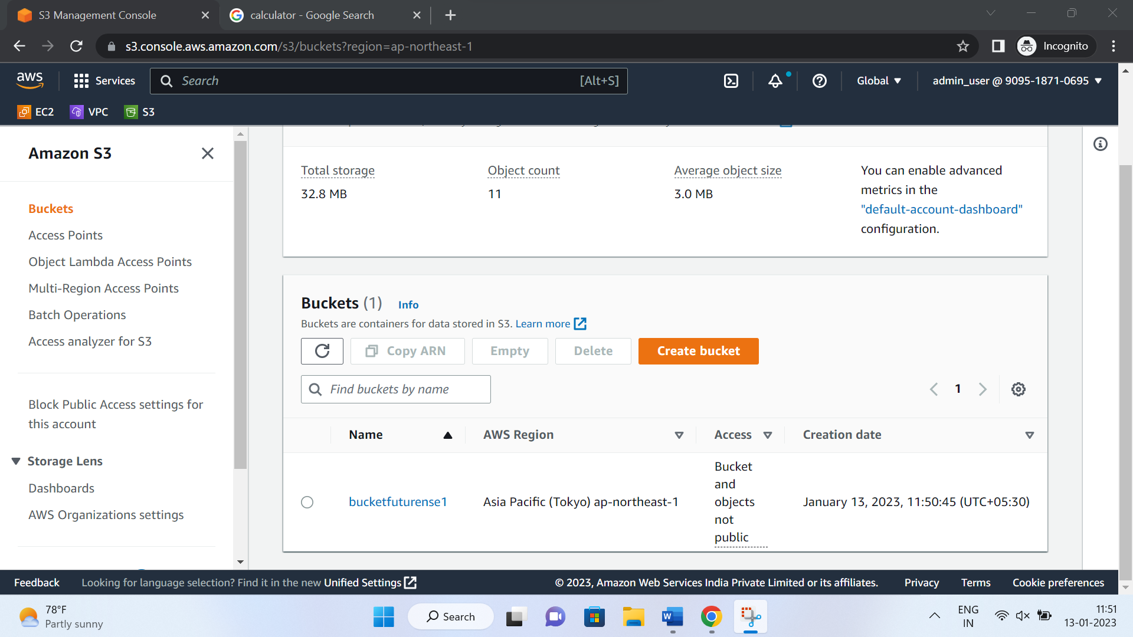

10. Upload a file as an object and share its URL

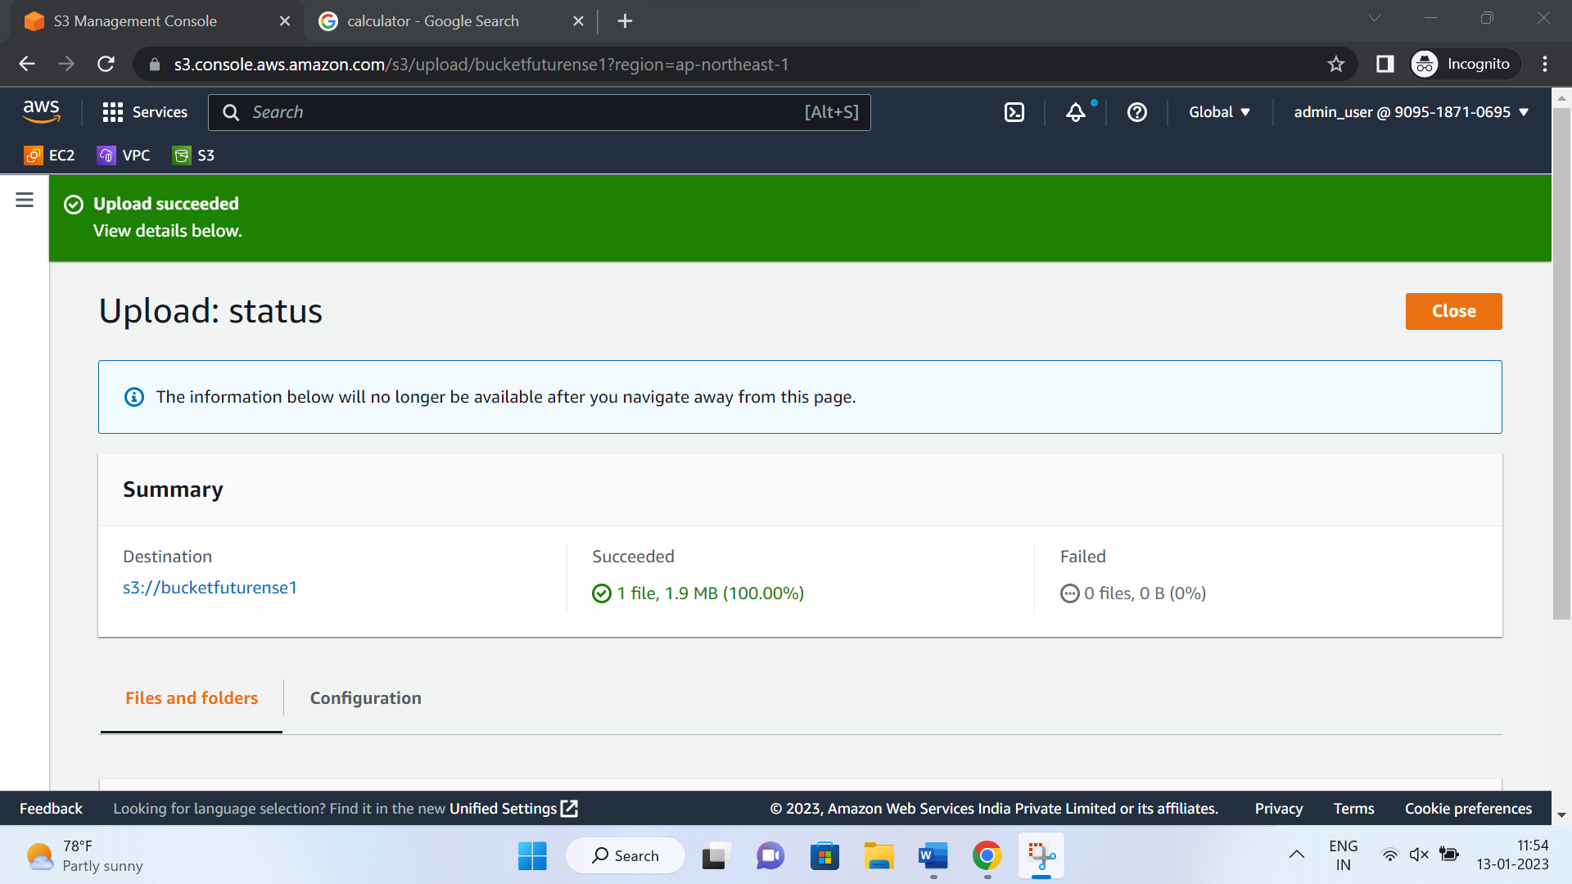

11. Give public access to bucket and object

Link - <https://futurensebucket001.s3.ap-northeast-1.amazonaws.com/dopeHoodie.gif>

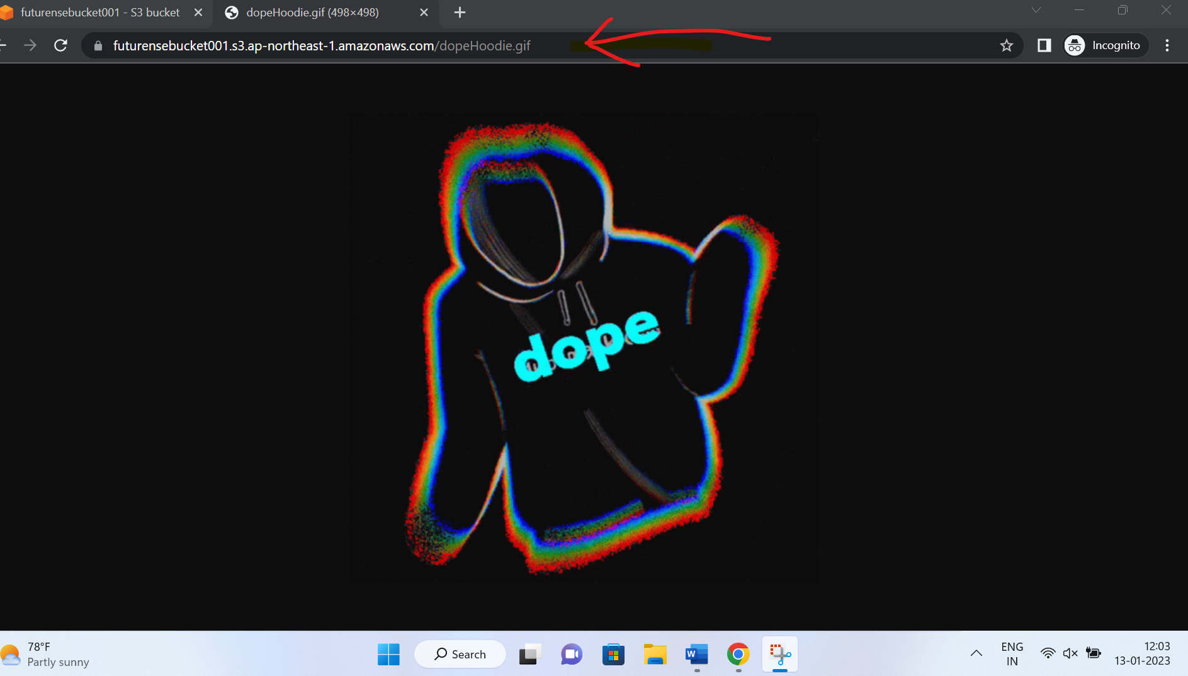

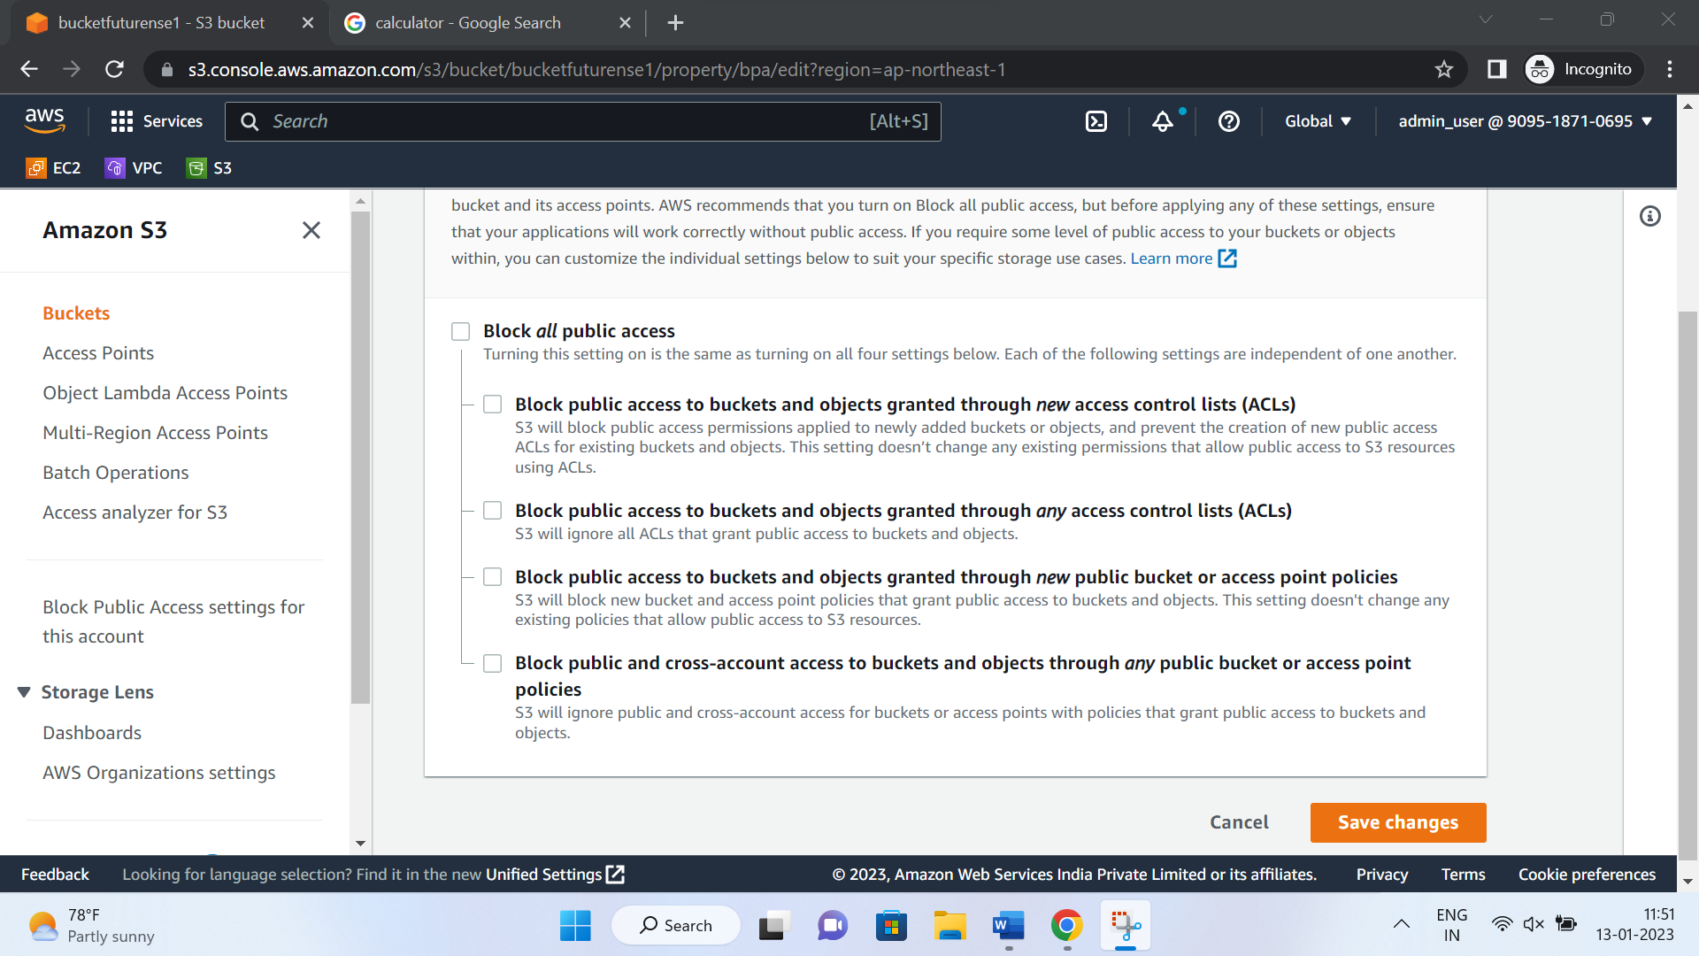

12. Host the object by sharing object URL